Heroes of Pymoli is a free-to-play newly released game. Although it is free, players are encouraged to purchase optional items that enhance their playing experience. This report will analyze the user and user purchase behavior of the game in it’s early stages, resulting in recommendations to optimize use and revenue.

**Description of Data**

We have been given the purchase data of the first 780 purchases by username, age, gender, item ID, item name, and purchasing price.

Quantitate Data

**Price:** the amount spent by purchase

Qualitative/Categorical Data

**Purchase ID:** the numbered list of purchases in chronological order

**SN:** the username unique to each player

**Age:** the age of each player

**Gender:** the gender of each player

**Item ID:** unique code associated with each purchased item

**Item Name**: unique title/ description associated with each purchased item

**Methodology/ Strategy**

To analyze the dataset, we will isolate and combine certain variables to glean insights.

1. First, we will aggregate the total unique players and purchases to identify average dollar amount of each purchase.
2. We will then categorize the data by gender to identify the largest gender group making purchases.
3. Then we will evaluate the gender groups against the same criteria (number of purchases, average price, total purchase, and average purchase) to see if there is any difference in behavior by gender.
4. We also categorize the data by age group to identify the age group of our largest audience that is making purchases
5. Then we will evaluate the age groups against the same criteria (number of purchases, average price, total purchase, and average purchase) to see if there is any difference in behavior by gender.
6. We will then identify the players that spent the most by grouping by screenname.
7. Lastly, we will group by item name and number to identify the products that are driving the most purchases and the highest revenue.

**Analysis**

When first looking at the data, we see that the average amount spent per purchase is $3.05. 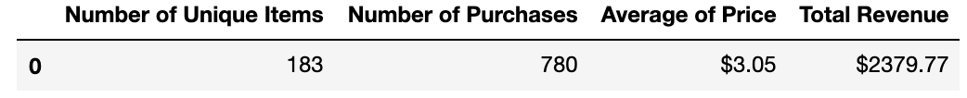

The player audience skewing largely male (84.03%) Despite females averaging a slightly higher value purchase per purchase (and other/ non-disclosed genders had highest on average), the males spent more per person in total.

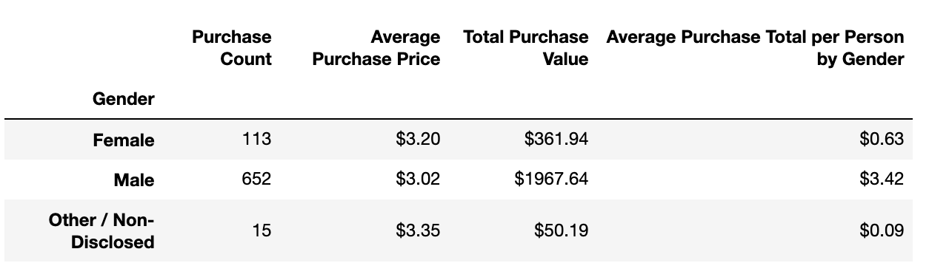

The majority of players making purchases were between the ages of 20-24, and this age group spent the most per person in total. Though, players 34-39 were more willing to make a slightly more expensive purchase on average.

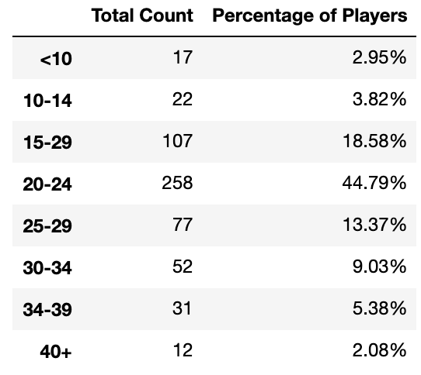 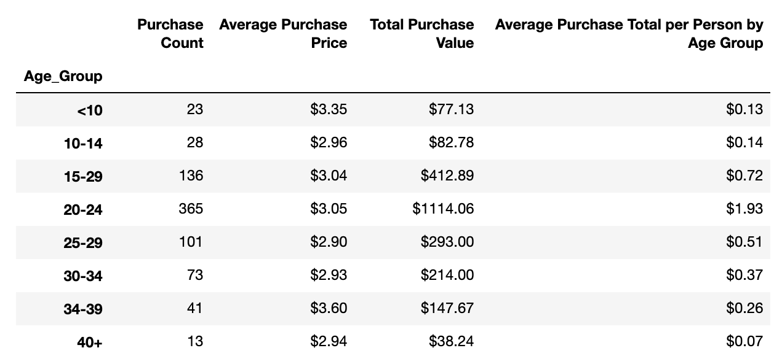

The most valauble players (MVP) in the game had a purchasing frequency of >1 and many purchaing above average priced items.

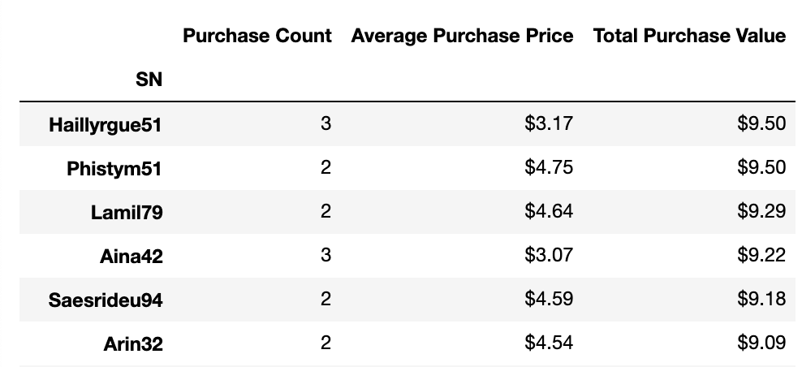

The most popular item to purchase is the Oathbreaker, which is priced above average.

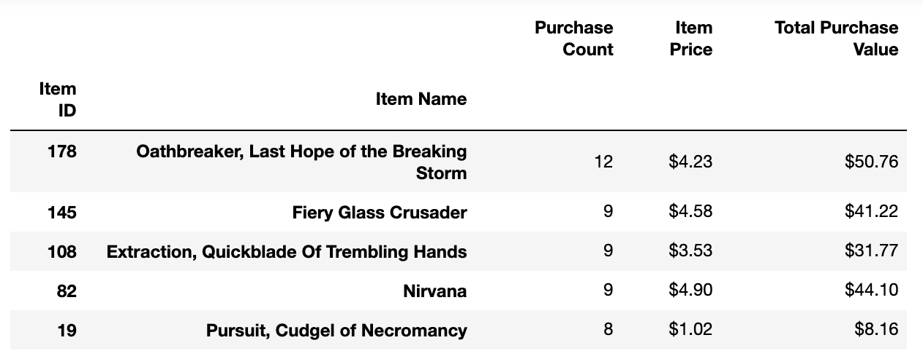

The most profitable item purchased is higher than average price, but the second most profitable is well below-average price.

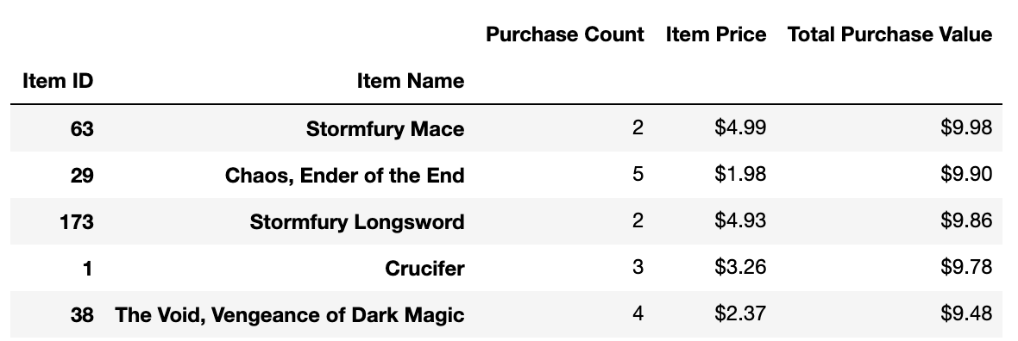

**Conclusion**

* Knowing that men are driving the majority or purchases and overall profitability, market to the male demographic to grow player base.
* Market potentially higher priced but specialized items to the women and people 34-39 years of age since they are willing to pay a bit more per purchase on average.
* Target more lower priced items to ages 15-29 since they are the ones making the majority of the purchases, but have below average purchase by person amounts.
* A retargeting strategy might be implemented to push +1 more purchase to those who have already made a purchase, seeing that even one additional purchase can increase the likelihood of being an MVP (based on purchase value).